**Title of the article:** *UAE Foreign Direct Investment climbs 116% in the past decade*

**Date the article was published:** *5th August 2022*

**Date the commentary was written:** *21st January 2023*

**Word Count of commentary:** *800 words*

**Unit of syllabus to which the article relates:** *Global Economy*

**Key-concept being used:** *Economic well-being*

**Article Link:** <https://www.thenationalnews.com/business/economy/2022/08/05/uae-foreign-direct-investment-climbs-116-in-the-past-decade/>

**Article -**

Foreign direct investment in the UAE has increased by 116 per cent in the past decade, as the country’s economy continues to grow despite pandemic-driven headwinds.

Total FDI rose to $20.7 billion in 2021 from $9.6bn in 2012, state news agency Wam reported on Friday, citing a report from the Ministry of Economy.

FDI in the Arab world’s second largest economy climbed to $9.8bn in 2013, $11bn in 2014, $8.5bn in 2015 and $9.6bn in 2016. The value of FDI reached $10.35bn in 2017, $10.38bn in 2018, $17.9bn in 2019, and $19.9bn in 2020, the data showed.

The UAE was ranked 19th globally in the list of top 20 countries that attract FDIs, and the first in West Asia and the Middle East and North Africa region, the UN Conference on Trade and Development's [*World Investment Report*](https://www.moec.gov.ae/en/-/unctad-investment-report-2022-ranks-uae-first-in-the-arab-world-and-19th-globally-in-attracting-fdi) said.

Kearney's FDI Confidence Index for 2021 also ranked the UAE first in the Arab world and 15th globally, advancing four places compared with 2020. It outperformed major global economies such as Singapore, Australia, Portugal, Denmark, Ireland, Brazil and Finland in the overall ranking.

The UAE is undertaking various measures to boost FDI inflows. Last year, it [unveiled a new strategy](https://www.thenationalnews.com/uae/uae-leaders-launch-plan-to-boost-industrial-sector-to-dh300bn-1.1188931) to attract investment in the industrial sector and increase its contribution to Dh300bn ($81.68bn) from Dh133bn in the next 10 years.

The country [overhauled its commercial companies' law](https://www.thenationalnews.com/business/economy/uae-revamps-foreign-ownership-rules-for-commercial-companies-1.1116335) in 2020 to attract more foreign capital and annulled the requirement for onshore companies to have an Emirati shareholder. It also announced legal reforms to help the country attract more FDI and support the growth of small- and medium-sized enterprises last year.

Its economy, which expanded by 3.8 per cent in 2021, is forecast to grow by 5.4 per cent and 4.2 per cent in 2022 and 2023, respectively, the latest projections from the country’s central bank showed.

The International Monetary Fund expects the UAE’s economy to grow 4.2 per cent this year and 3.8 per cent next year.

The country is also signing new trade deals to support the economy and boost investments. It signed Comprehensive Economic Partnership Agreements with India, Israel and Indonesia this year and is negotiating with other countries on similar deals.

The growth in FDI inflows to the UAE reflects the confidence of the international community in its investment environment, Thani Al Zeyoudi, Minister of State for Foreign Trade, said in April.

New legislation and the launch of the [Projects of the 50 campaign](https://www.thenationalnews.com/uae/government/2021/09/02/uae-leaders-reveal-50-new-national-projects-are-in-the-works/) are set to have a concrete effect in the long term on the flow and quality of foreign and domestic investments as well as the UAE’s overall economic growth, he said.

**Commentary -**

The article above is about foreign direct investment (FDI) into the UAE. FDI refers to investments in productive facilities such as buildings, factories and other physical capital done by multinational corporations (MNCs). FDI affects economic growth, which affects **economic well-being**. **Economic well-being** refers to levels of living standards and economic satisfaction among members of an economy.

The article mentions FDI in the UAE has increased by "116 percent" in the past decade due to improvements in trade liberalization (overhauling its companies’ commercial law). This increases long-term economic growth in the country as it encourages competition, hence likely improving efficiency. It also increases investment spending, positively affecting aggregate demand (AD) leading to short-term economic growth. This is indicated by the text saying that the economy has "expanded by 3.8 percent”, meaning an increase in Real GDP. Long-term economic growth can be illustrated as follows -

**Figure 1:** Long-term economic growth

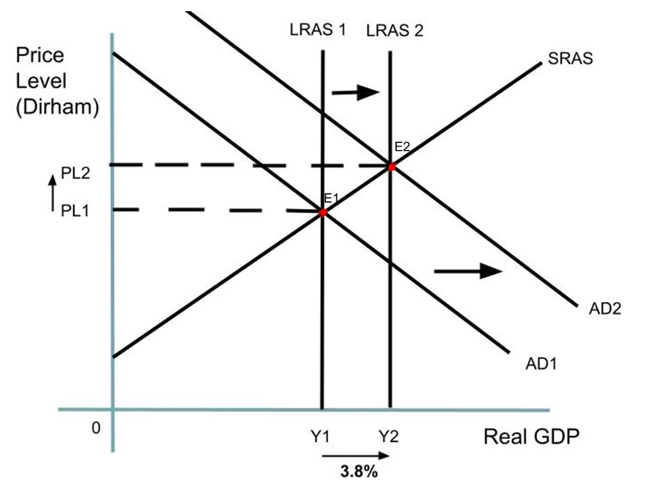

The economy is initially at Price level PL1 and Real GDP Y1 determined by the intersection of LRAS1, AD1 and SRAS at E1. FDI increases investment spending “in the industrial sector” in the UAE. This shifts AD1 to the right to AD2. Additionally, the increase in the quantity of capital goods, a factor of production, present in the economy can help shift LRAS1 to the right to LRAS2 as it allows producers to produce more goods and services in the long-term. This leads to a new long-term equilibrium determined by the intersection of LRAS2 and AD2 at increased price level PL2 and increased Real GDP Y2 at E2.

The relation between FDI and **economic well-being** is extremely relevant here. FDI can generate long-term economic growth which could improve living standards as it corresponds to more goods and services produced in the economy. This could increase employment opportunities in the UAE, as to produce more goods and services, more labour is required. This reduces unemployment, increases income, and helps lower income households escape the poverty cycle as increased income and employment allows them to consume more merit goods and services such as health and education, improving their **economic well-being**.

FDI has some positive effects on the citizens of the UAE. Since FDI increases economic growth in the UAE, if the speed at which the population grows is lower than the increase in Real GDP, this increases per capita income of households, increasing their disposable income and allowing them to consume more goods and services, increasing levels of **economic well-being** in the country.

Increased FDI allows foreign firms to bring various types of technologies into the UAE which could help domestic firms produce more efficiently, but UAE must ensure they use technology appropriate for their economic, ecological, and environmental conditions to take advantage.

Though FDI has positive effects, there are disadvantages associated with FDI. FDI firms often undertake profit repatriation. This results in an income outflow from the circular flow, reducing total income in the UAE. This means that FDI may not benefit local citizens as much as expected. Another disadvantage of FDI is that if the UAE is overly reliant on FDI, it could be dangerous as FDI’s are vulnerable to external shocks. If the home country of an FDI firm is in a demand shock, it is possible that the FDI firm cuts down wages and sends back more of its profits to its home country. This could reduce living standards and economic wellbeing in the UAE. Lastly, FDI causes more efficient foreign firms with lower costs of production to invest in the UAE. This could negatively affect domestic producers as they lose sales due to their higher costs of production and higher prices of goods and services.

In the short-term, there are gains from FDI in the UAE through increased employment opportunities. It also has a positive impact on investment spending in the short-term, hence helps shift AD to the right and achieve short-term economic growth. In the long-term, FDI can move LRAS to the right due to improvements in technology and efficiency, hence generating long-term economic growth and increasing equilibrium level of output. However, in the long-term FDI may not be sustainable as it could lead to overexploitation of resources and is highly susceptible to external shocks. Additionally, in the long-run FDI could lead to an increase in the supply of Dirham’s, hence resulting in depreciation. Depreciation could increase the real value of debt, which could result in less government spending on merit goods.

In conclusion, the effect of FDI on the UAEs economy is positive. It can help increase employment, reduce poverty, and promote long-term growth. Though the UAE is “signing new trade deals”, the country must be cautious of not being overly reliant on FDIs to achieve economic growth. If the country is overly reliant on FDIs, it could greatly reduce its ability to produce goods and services during a global recession.